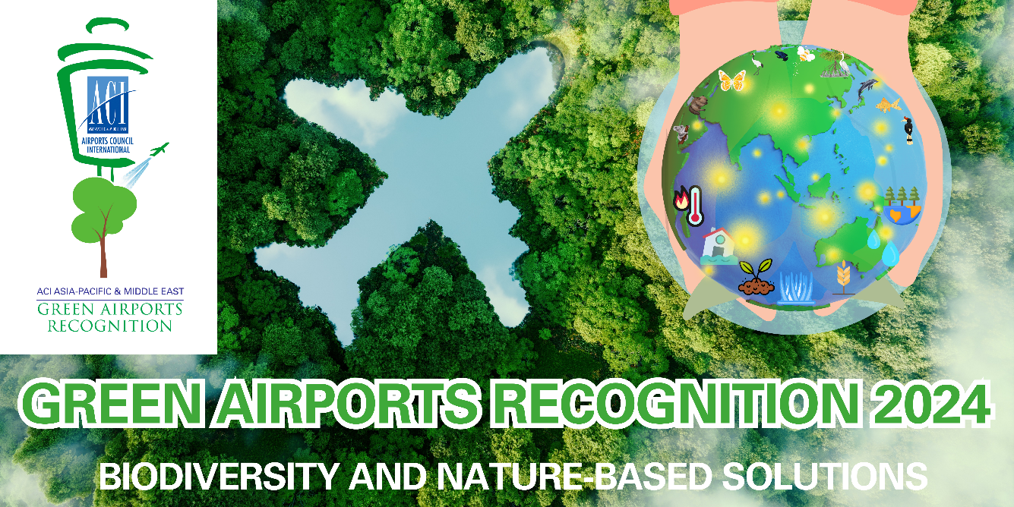
Part I- Programme Description
Background and Objective
The Green Airports Recognition promotes environmental best practices to minimise aviation’s impact on the environment and recognises airport members who have outstanding accomplishments in environmental projects.
This initiative allows airports to share environmental projects with other airports in the region and be recognised for their achievements.

Initiative Topics - Environment
The environmental field encompasses the following key themes, from which a topic will be selected for the Green Airports Recognition each year:
- Environmental Policy and Management (including green procurement)
- Noise
- Air quality
- Waste
- Water (including both municipal water usage and wastewater discharge)
- Energy
- Carbon
- Biodiversity
- Ground Transportation
- Land & water contamination
- Others
Green Airports Recognition 2024
Theme: Biodiversity and Nature-Based Solutions
Biodiversity is under serious threat due to human activities. Pollution, climate change, deforestation and habitat loss, over-exploitation and invasive species are some of the key risks. According to the United Nations Development Programme, 13 million hectares of forests are lost every year, desertification affects almost 4 billion hectares, while around 7,000 species of animals and plants are illegally traded.

Biodiversity at the local level is affected by airports as they often occupy large open areas near natural ecosystems. Wildlife trafficking is also a relevant global topic as wildlife traffickers exploit the connectivity of the global aviation networks and airports as hubs to perform this illegal activity, causing serious environmental damage, adversely affecting communities that live from wildlife tourism, and causing similar effects to other international crimes, including promoting instability and financing organised crimes. This involves as well economic and reputational risks for airports.

The United Nations Sustainable Development Goal 15 of the 2030 Agenda is devoted to “protect, restore and promote sustainable use of terrestrial ecosystems, sustainably manage forests, combat desertification, and halt and reverse land degradation and halt biodiversity loss”.
The United Nations Environment Assembly (“UNEA”) adopted Nature-Based Solutions for supporting sustainable development in Resolution 5/5 on 2 March 2022 and the first global consultation meeting on Nature-Based Solutions convened by the United Nations Environment Programme (“UNEP”) on 16th May 2023.
The resolution provides the first multilaterally agreed definition of Nature-Based Solutions’ as “actions to protect, conserve, restore, sustainably use and manage natural or modified terrestrial, freshwater, coastal and marine ecosystems which address social, economic and environmental challenges effectively and adaptively, while simultaneously providing human well-being, ecosystem services, resilience, and biodiversity benefits”.
By implementing Nature-Based Solutions, airports can contribute to local and regional biodiversity conservation while maintaining efficient and safe operations. This approach aligns with broader goals of sustainability and environmental step forward in the aviation industry.
Aside from the classic ecosystem restoration, a concrete illustration of a Nature-Based Solutions within the airport industry involves incorporating green infrastructure, such as bio-swales or vegetated swales. Bio-swales are landscape elements specifically crafted to control stormwater runoff, filter out pollutants, and encourage the replenishment of groundwater. In airport environments, these environmentally friendly features can be tactically blended into the landscape to improve stormwater control, minimize the potential for flooding, and advance the overall sustainability of the environment. The utilization of vegetation in this context not only fulfils practical objectives but also plays a role in maintaining the ecological equilibrium of the airport surroundings and removing carbon from the atmosphere.
The Green Airports Recognition 2024 is an opportunity for airports from Asia-Pacific and the Middle East to share their successful journey towards preserving biodiversity and exploring best practices of utilizing Nature-Based Solutions in the aviation industry.

The call for Green Airports Recognition 2024 submissions is now open!

All eligible airports across Asia-Pacific and the Middle East are invited to participate, by submitting their revolutionary initiatives and projects on Biodiversity and Nature-Based Solutions. We encourage airports to submit their best practices in preserving Biodiversity and utilizing Nature-Based Solutions at their premises ranging from wetland restoration and creation, balancing wildlife species and airport operation, wildlife trafficking prevention, ecosystems restoration or carbon removal through Nature-Based Solutions.

Eligibility
- Applicants must be active ACI Asia-Pacific & Middle East’s airport members
- Applicants must complete Environmental Survey 2023
- Submitted project or initiative must be completed within the last five years (2019-2023)

How to Apply
The participating airport is required to submit the completed application form to ACI Asia-Pacific & Middle East.

Important Dates
Submission deadline: 23 December 2023, 12:00 noon HKG Time (GMT+8)
Result announcement: Within Q1 2024
Presentation ceremony: To be confirmed
Judging Process and Criteria
Eligibility review: All applications will be reviewed for their eligibility (project completion date, word limit prescribed etc.) by ACI Asia-Pacific & Middle East.
Panel assessment: Each eligible submission will be evaluated based on the judging criteria by a Panel comprising ACI, academia and experts in the airport environmental field worldwide.
Nominated environmental projects will be assessed based on the following seven criteria, on a scale of 0 to 4 (4 = Excellent; 3 = Good; 2 = Satisfactory; 1 = Fair; 0 = No evidence).
- Environmental Awareness & Benefit
- Company Management Involvement
- Cost Effectiveness
- Innovation
- Stakeholder Engagement
- Social Benefit
- Applicability

Award Categories
Platinum, Gold and Silver recognitions will be given to the three highest-scoring airports in each size category (depending on the number of participants) based on the judging criteria.
Selected submissions will be featured in the Green Airports Recognition publication and outstanding airports will be recognised with our sustainability credential and be invited to the award presentation ceremony at the ACI Asia-Pacific & Middle East Regional Assembly, along with their achievements highlighted in ACI’s press campaign.

Enquiries
For enquiries, please contact Mr. Ken Lau, Senior Manager, Environment and Airport Information Technology at green_airports@aci-asiapac.aero .

Part II – Application Form
Section A – Entrant Particular
Airport Operator:
Airport: | IATA code:
Contact Person (Name & Designation):
Tel. No.: | Email:
Section B – Project details
Name: | Completed date:
Website link (if any)
Section C – Declarations
By submission of this form, I agree to the report being published and publicised at the discretion of ACI Asia-Pacific & Middle East. I agree that ACI Asia-Pacific & Middle East and/ or the Panel of Judges have full authority to make final decisions on all matters relating to the “ACI Asia-Pacific & Middle East Green Airports Recognition” without obligation to disclose the reasons.
Signature of Official/ Alternate Representative: |  | Name:
 |  | Designation:
 |  | Date:
Section D – Important Note
- Please submit (1) a completed Application Form in MSWord and (2) a scanned copy of this page with a signature of ACI Asia-Pacific & Middle East Official or Alternate Representative to green_airports@aci-asiapac.aero on or before Friday 23 December 2023, 12:00 noon Hong Kong Time (GMT+8).
- Please provide details of only one project in one application.
- Please contact us if you do not receive an acknowledgement email with a reference number from the ACI Asia-Pacific & Middle East Regional Office within three working days after your submission.

Executive Summary
Provide a brief summary of the project for ACI’s future publications. (max 300 words)
Project Background
Describe where, when and why the project was needed. (max 100 words)

Project Scope
Describe the operational boundary of the project, e.g. airside only, terminal only, airport-wide etc. and stakeholders involved, e.g. airport staff, regulators, NGOs and environmental groups etc. (max 50 words)

Project Description
Describe how the project was delivered, e.g. retrofit, new project as well as funding. (max 150 words)

Project Results and Benefits
List your project achievements and supporting evidence and summarize its relevance to the judging criteria, e.g., factual data, actual cost saved, recognized environmental benefits and evidence of innovation. (max 300 words)

Project graphics
Maximum 4 graphics with captions e.g., photos, charts etc. This part will be considered for future ACI publications. Provide a caption for each graphic.
Caption 1: | Caption 2:
INSERT A PICTURE HERE | INSERT A PICTURE HERE
Caption 3: | Caption 4:
INSERT A PICTURE HERE | INSERT A PICTURE HERE

